Clemson University
Lucas Kanade Feature Point Detection and Tracking
Assignment 6, ECE 847
Ujwal C Naik
Assignment Number 6

Report for the 6th assignment for Digital Image Processing

Introduction:
In this assignment we implement the Lucas-Kanade algorithm to detect certain feature points and track their motion through a sequence of images, which are frames from a video.
The aim of this assignment is to implement optical flow based tracking algorithm namely Lucas-Kanade on a sequence of frames obtained from a video. Using our knowledge of eigenvalues we detect features which we must track. Then these feature points are tracked through several frames of video by the Lucas Kanade algorithm that iteratively tries to calculate the motion between two frames.

Method:
As is the case with all computer vision algorithms, Lucas Kanade also works with a few assumptions.
- Spatial Coherence: The algorithm assumes that neighboring pixels tend to have similar motion.
- Temporal Persistence: The displacement of the feature points being tracked is small/gradual through the frames. The algorithm cannot track the feature points if the motion is too large.
- Brightness Constancy: The brightness of the pixel does not change as it moves from one frame to another.

Lucas Kanade Approach:
- Lucas Kanade makes use of the Newton Raphson method in which we estimate the location of the feature point in the next frame given its current pixel location and error value based on the gradient values. The process is run iteratively for each feature point till convergence, on every frame in the image.
- For each feature the following equations are solved for every frame: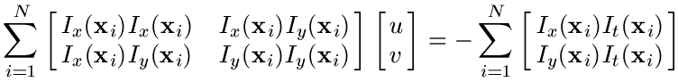
Where N is the number of feature points.

Algorithm:
The algorithm for Lucas Kanade can be explained in 2 parts:
- Feature Detection:
- Compute the gradients of the given input image.
- From the gradient images obtain the eigen values using the formula:
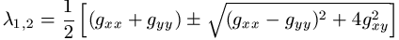
- Sort the eigen values according to intensity.
- Out of these eigen values we select 100 points such that the is a distance of atleast 8 pixels
everyside of the feature point we have selected.
- Tracking the feature points:
- Compute the gradients of the first image that is inputted to the feature tracker.
- Interpolate the images and the gradients of the images.
- Calculate the 2x2 gradient covariance matrix.
- Calculate the error vector at every point in the window.
- Calculate the unknown velocities ddx and ddy. ddx and ddy signify the change in velocities and the resultant velocity is given by dx +=ddx and dy+=ddy.
The values of ddx and ddy are obtained by solving the equations:
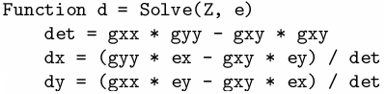
- The 2nd image is then interpolated over the same window by taking dx and dy into account.
- Steps 4 to 6 are carried out iteratively till convergence.
- Once the location of the next frame is obtained the image is displayed.
This is how the features get tracked in the image using the Lucas Kanade algorithm.

RESULTS
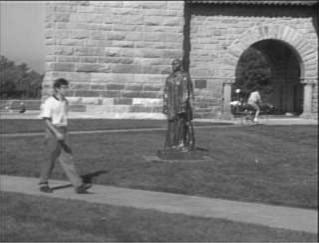

Orignal Image.

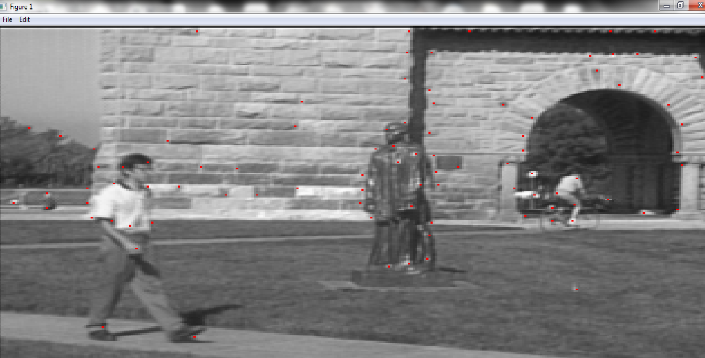
First frame with feature points indicated by red pixels.

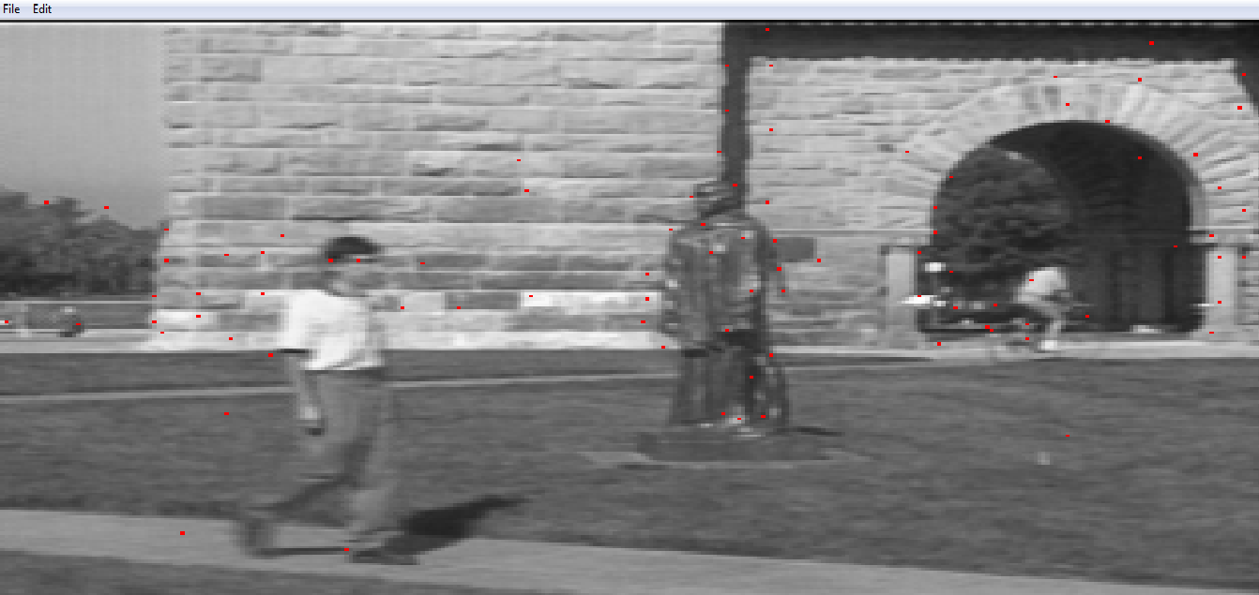
Tracking result in the 10th frame.

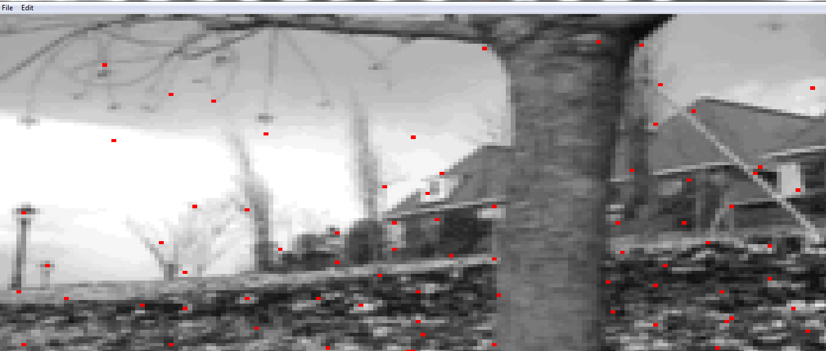
Result of Feature Detection on 1st frame.

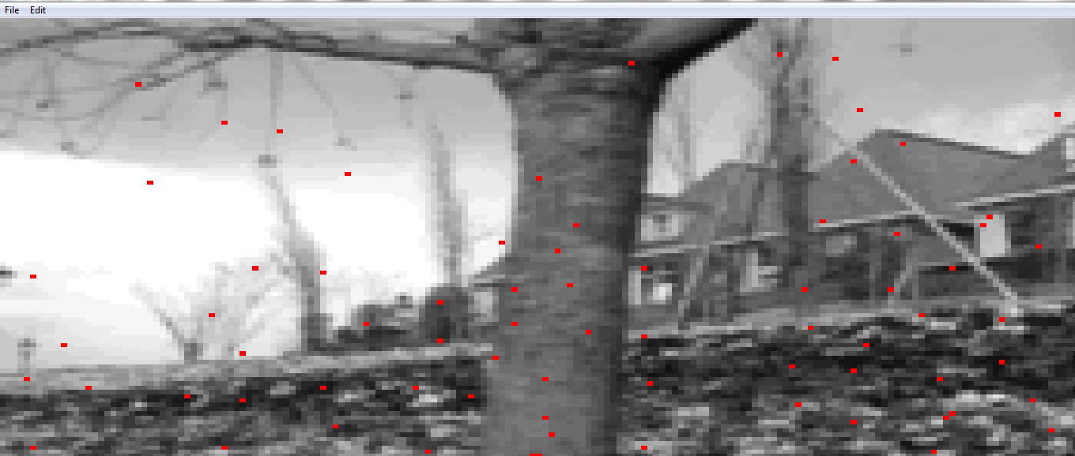
Result of tracking in the 10th frame.

Conclusion
Lucas Kanade was implemented successfully to track certain feature points in the image sequence.
The objects close to the camera have very high relative velocity and hence are harder to track as compared to the objects in the background which have a lower relative velocity. Therefore, tracking the statue sequence is a lot harder than tracking the house in the other sequence.
Also, the algorithm wasn’t able to track all the feature points due to either lack of texture at some positions or failure to converge due to some-other reason.

